# ­­­RAY THEORY

## ­­­

Content

## Introduction

### Ray Theory Fundamentals

## General ray theory model FOR a multilayered case

Ray Theory Fundamentals

(From Slotnick, 1936; Officer 1958, 1980; Aki and Richards, 1980; Cerveny (200?), Lay and Wallace,1995; Ikelle and Amundsen, 2005)

At any given moment in time after the initiation of a wave, from a controlled source, the locus of all field points in phase forms a wavefront. With additional time increments, in isotropic systems new wavefronts are generated in a direction at right angles to the points on the former wavefront and we can track the new point on the new wavefront using *rays* or *bundles of rays*.

In a 1D layered medium, the horizontal ray parameter: *p* does not change for a given ray that starts at the surface with a given take-off angle.

, (1)

where *i* indicates the number of the layer that the ray is traveling.

A vertical ray parameter also exists:

, where



Where *1/Vi* is known as the “slowness” of the ray.

Also note that from (1) we can also write 

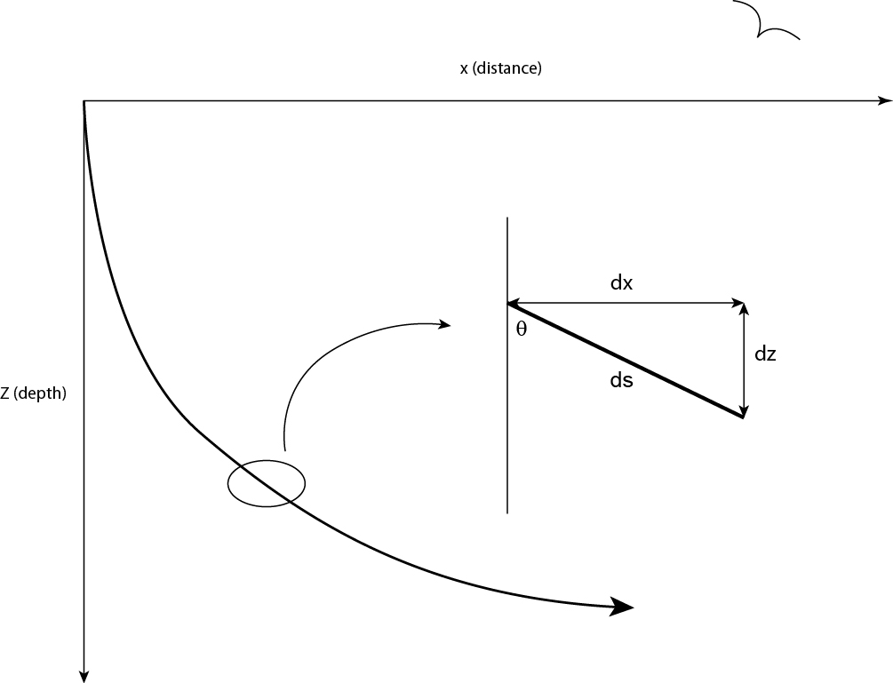

In a horizontally layered flat earth at any point, we can break down the a ray into various components:







Remember (1) so that the now (1.1-1.3) become

 , and

 (use trigonometric identity: )

and



If we want to estimate the either the horizontal increment in distance or the vertical increment in distance that a segment of a ray experiences, over a short distance we can see that:



If we want to estimate the amount of time that passes over the segment of the ray:











Or, 





## General ray theory model FOR a multilayered case

For each layer in which the ray travels we calculate the length of time it spends in the layer and both the horizontal distance and vertical distance that the ray travels.

In a 1-D velocity-depth model for the earth there will be a point along its path where the ray can not penetrate the earth any further. This point is known as the turning point, or the location where the ray bottoms out. Regardless of the location, the ray will be travelling horizontally at this point or maximum penetration into the earth. Also according to Snell’s Law at this point:



However, remember that along any ray path, Snell’s law means that the ray parameter does NOT change ANYWHERE. So, we deduce that



In a horizontally layered model where the velocity in each layer does not change laterally we expect the downgoing ray path to be symmetrically identical about the turning point to the upgoing ray path. The total horizontal distance (*X*) will then be twice the sum of the individual horizontal distances travelled up to the turning point. The total time (*T*) will also be twice the time taken to reach the turning point. So we have that:





We can examine how this works by considering a single-layer case (n=1). In this case, for a given p we can calculate the expected distance away from the source that the signal will arrive back at the surface and how long it will take to do so. So, parametrically, through the estimation of T and X a continuous set of arrival points in X-T space can be constructed.



, for any *p*