Petroleum Seismology, spring 2010
Homework #2

Purpose: Review Vector Algebra
Q. 1 Demonstrate that the following identities are true with an example.
You can use Matlab, or Mathematica, or Excel, etc. or your own example,

1)
Proof:
So in all the 27 possibilities, only the 6 shown above is none zero
So
2)
Proof:
Q. 2. Rotate the following vector clockwise by 25 degrees about the third axis..
(1 2 3)
Calculate the magnitude of the vector.
Use Excel, Matlab or Mathematica to carry out the rotation.
Hand in your code and results.

Here are the Matlab codes:
********************************
* hw2.m
********************************
%Purpose: Caculate the magnitude of the vector and rotate it along the z
% axis
%Author:Guofeng Yuan
%Date:02/04/2010

%the vector
clear;
clc;
a=[0,0,0];
b=[1,2,3];
%The magnitude of the vector
mag1=norm(b);
%Draw the first vector
vectarrow(a,b,'red');
hold on;
%Rotation angle
theta=25*pi/180;
%The rotation matrix
A=[cos(theta),sin(theta),0;-sin(theta),cos(theta),0;0,0,1];
c=A*b';
%The vector after rotation
d=c';
mag2=norm(d);
%Draw the second vector
vectarrow(a,d,'blue');
%Add title and legend
leg=legend('Before Rotation','After Rotation');
h=title({'Vector (1,2,3) Rotated Clockwise by 25 degrees about z axis '; ['The Magnitude of this Vector is ',num2str(mag1),'']});
set(h,'fontsize',18);
set(leg,'fontsize',20);
hold off;

set(gcf,'PaperUnits','inches','PaperPosition',[0 0 12 12])
print -djpeg 'myfig.jpg' -r100
********************************
Here I used a function to draw the vector which I got from a example from mathworks website, and I modified it to fit my needs.
http://www.mathworks.com/matlabcentral/fileexchange/7470-plot-2d3d-vector-with-arrow
********************************
* vectarrow.m
********************************
function vectarrow(p0,p1,clr)
%Purpose: Arrowline 3-D vector plot.
% Author: Rentian Xiong 04/18/2005
% Modified by:Guofeng Yuan 02/04/2010

if max(size(p0))==3
if max(size(p1))==3
x0 = p0(1);
y0 = p0(2);
z0 = p0(3);
x1 = p1(1);
y1 = p1(2);
z1 = p1(3);
colorplot=plot3([x0;x1],[y0;y1],[z0;z1]); % Draw a line between p0 and p1
set(colorplot,'Color',clr);
p = p1-p0;
alpha = 0.1; % Size of arrow head relative to the length of the vector
beta = 0.1; % Width of the base of the arrow head relative to the length

hu = [x1-alpha*(p(1)+beta*(p(2)+eps)); x1; x1-alpha*(p(1)-beta*(p(2)+eps))];
hv = [y1-alpha*(p(2)-beta*(p(1)+eps)); y1; y1-alpha*(p(2)+beta*(p(1)+eps))];
hw = [z1-alpha*p(3);z1;z1-alpha*p(3)];
hold on
arrowplot=plot3(hu(:),hv(:),hw(:),'HandleVisibility','off') % Plot arrow head
grid on
xlabel('x')
ylabel('y')
zlabel('z')
set(arrowplot,'Color',clr);
hold off;

else
error('p0 and p1 must have the same dimension')
end
else
error('this function only accepts 3D vector')
end
********************************
Here is the output image
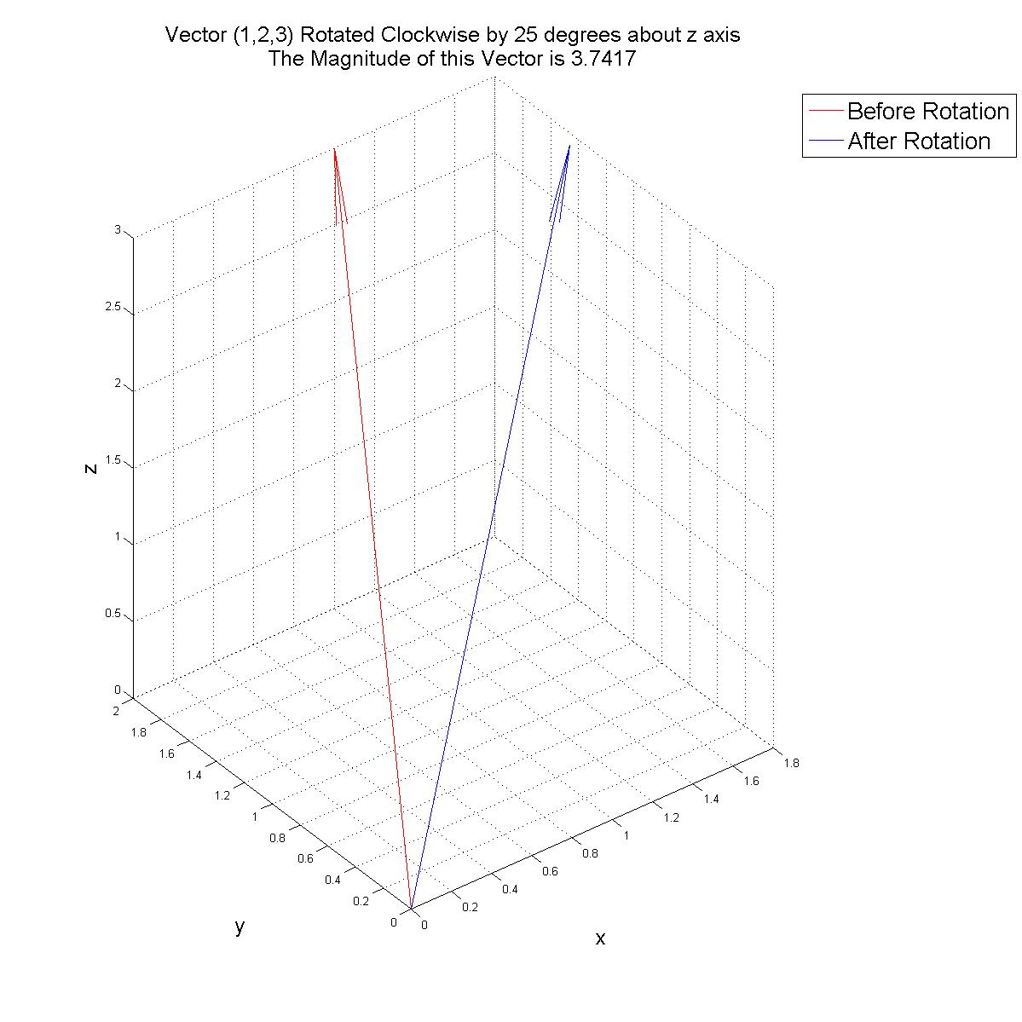
Fig.1 Vector(1,2,3) rotated by 25 degree clockwise about z axis, the magnitude of the vector is 3.74

